# Door Order Form

Use the form below to select the type of door required, along with the colour, hardware and the dimensions. Once the form is completed, please send to [irishcottagedoors@gmail.com](mailto:irishcottagedoors@gmail.com) . If any assistance is required, please contact the email address or call at 0872548973 or 0667119690.

# Select Door Type

Pick the number of the type of door that’s required. If another style is required, please contact email address or phone number above.

|  |  |
| --- | --- |
| Enter the number of the type door required |  |

**1**

**2**

**3**

**4**

**5**

**6**

# Door Layout

Select the type of layout for the door.

|  |  |
| --- | --- |
| Door Layout Number |  |

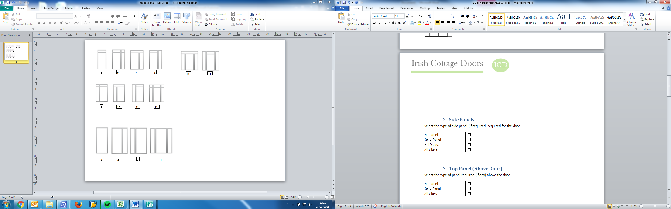

# 

# 

# 

# Side Panels

Select the type of side panel (if required) required for the door.

|  |  |
| --- | --- |
| No Panel |  |
| Solid Panel |  |
| Half Glass |  |
| All Glass |  |

# Top Panel (Above Door)

Select the type of panel required (if any) above the door.

|  |  |
| --- | --- |
| No Panel |  |
| Solid Panel |  |
| All Glass |  |

# Glass

Select the type of Glass required (if any) for the door.

|  |  |
| --- | --- |
| Clear |  |
| Obscure |  |

# Door Colour

Select the colour from a RAL chart for the interior and exterior of your door.

|  |  |
| --- | --- |
| Exterior Door Colour | RAL Number: Click here to enter text. |
| Interior Door Colour | RAL Number:Click here to enter text. |

# Frame Colour

Select the colour from a RAL chart for the frame of your door.

|  |  |
| --- | --- |
| Frame Colour | RAL Number: Click here to enter text. |

# Hardware Style

Select the hardware style (hinges, plates, handles) for your door.

|  |  |
| --- | --- |
| Black |  |
| White |  |
| Gold |  |
| Chrome |  |
| Old Style Hinges (€100 extra) |  |

# Insert your door dimensions

Measure and input the dimensions of your door in the boxes to the right. There is a how to measure guide below.

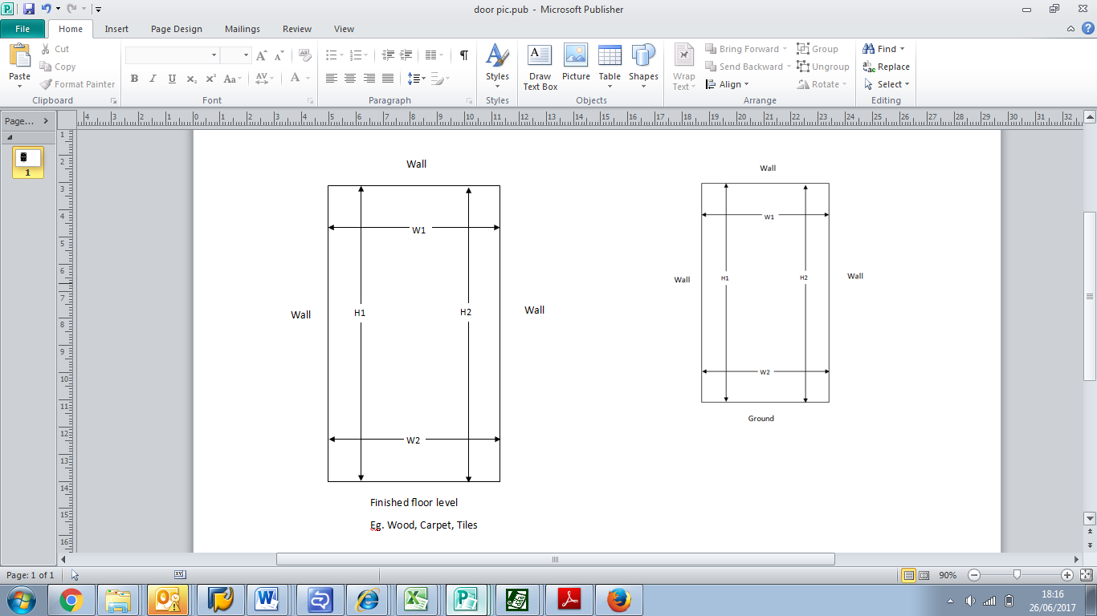

|  |  |
| --- | --- |
| Measure wall to ground on the left(H1) and right (H2) | |
| H1 (mm) |  |
| H2 (mm) |  |

#

|  |  |
| --- | --- |
| Measure wall to wall on the Top (W1) and bottom (W2) | |
| W1 (mm) |  |
| W2 (mm) |  |

# Door Split height

Input the height of the split in the cottage door required (Optional)

|  |  |
| --- | --- |
| Door Split Height | |
| H1 (mm) | Click here to enter text. |
| H2 (mm) | Click here to enter text. |

H2

H1